***Assignment – 15***

Using Subqueries with DML Commands.

1. Assume there is a table called Multicust, with all of the same column definitions as Salespeople. Write a command that inserts all salespeople with more than one customer into this table.

Ans 1)

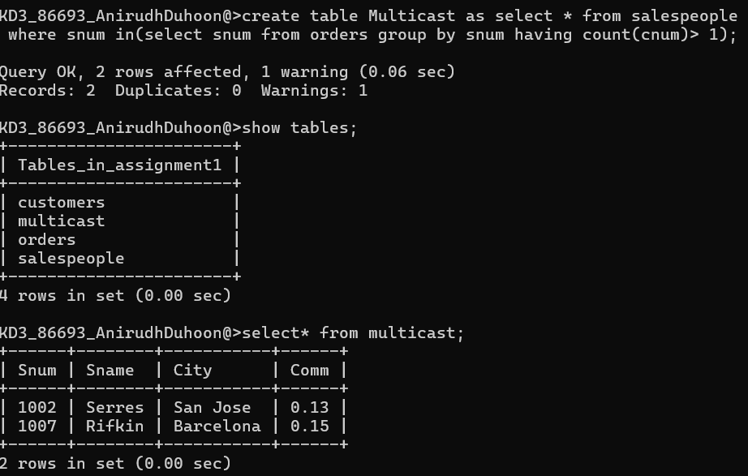

1. Write a command that deletes all customers with no current orders.

Ans 2) 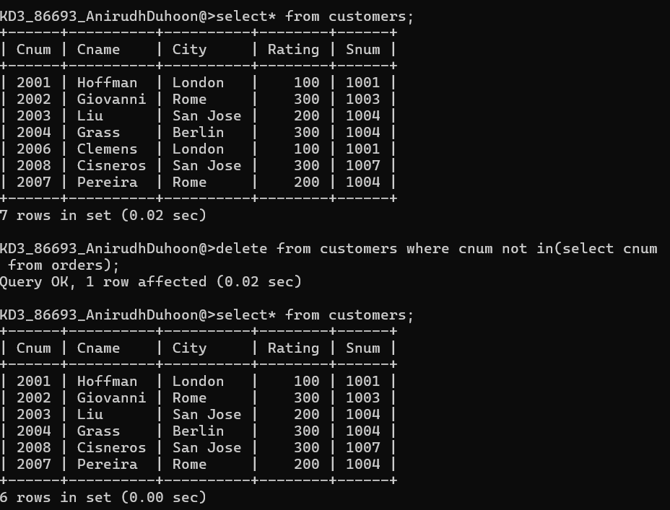

1. Write a command that increases by twenty percent the commissions of all salespeople with total orders above Rs. 3,000.

Ans 3) 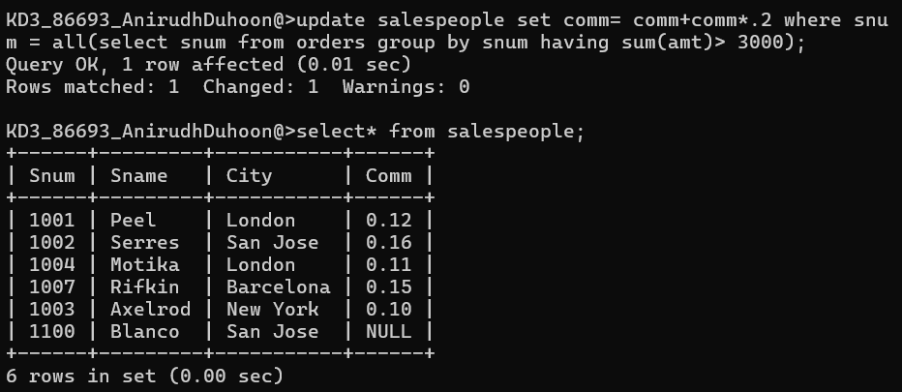

*Sameer Dehadrai* Page: 1